
The Friendly Echo
FRIENDSHIP FORCE OF WINNIPEG NEWSLETTER
Volume 12, Issue 6 June 2012

PRESIDENT’S MESSAGE

Greetings!

What a fantastic exchange we just had! A big thank-you goes out to Nancy, Bob and their committee for organizing such a successful and enjoyable exchange. Thank you to all our members for your participation in this exchange and especially to our new members, who have jumped right in and volunteered to be home hosts, day hosts, and dinner hosts. I heard many positive comments throughout the week from both members and ambassadors.

Thank you to Norma W for organizing the book sale and to Nancy for her presentation on Prague and Hertfordshire at the May meeting.

A special welcome is extended to our newest member, Shirley Esaruk.

After our picnic on June 13th there will be no more meetings until Aug 29th. However, Elizabeth and her committee will be planning our next inbound exchange in September for Lima Peru.

I hope that many of our members will be able to attend the BBQ hosted by FF Manitoba on June 20th at the Babij's in LaSalle.

Have a good summer everyone, and enjoy our wonderful Manitoba weather.

In friendship
Paul Havixbeck

Member Announcement
It is with deep regret that we inform the membership of the passing of the mothers of two of our members; Val Daniel and Judy Olmstead-Coss. Our condolences to both families.

Get Well Wishes
We hope that Bob Kury has a speedy and complete recovery from his recent surgery. His full participation during the recent exchange was missed. Get well Bob!

Thank-you Letters
Our Club received thank-you letters for donations made with the proceeds of our recent card party from Agape Table; The Salvation Army and Winnipeg Harvest. Winnipeg Harvest said that they are able to leverage a one dollar donation to twenty dollars worth of food.

Happy Birthday – Summer Celebrants

June
Karen Kaiser
Marilyn Zaharia

Bessie-Marie Hill
Joan Hanuman-Emeny
Robert Champagne
Muriel Moreau
Elizabeth Grover
Norm Pohl
Shirley Mitchell
Norma Warecki
Janice Leckie
Don Charleson
Gladys Thomas
August
July Joan Warden
Margaret Birk Alma Vincent
Dolores Hébert Irv Reschke
Rick Klimack Carol Frederickson
Martha Klimack

Upcoming Events

June 13 - A picnic and meeting for members and adult guests at 5:30 PM. Dolores Tutkaluk has kindly offered to host the event at her house in East St. Paul (near Birds Hill) at 87 Chrisluk Drive. Driving directions can be found on www.mapquest.com

Those who plan to attend should bring lawn chairs, plates, glasses/cups & cutlery as well as beverages of their choice. Tea, coffee and pop will be served. A small fee ($5-$10 per person) will be collected at the picnic to cover the cost of food.

June 20 – Friendship Force Manitoba has invited our club to their Mexican Pot Luck to be held at 37 Rrue Beaudry in La Salle MB at 6:00 PM. The wearing of Mexican attire would be welcomed. RSVP to the Babijs at 204-736-4276.

August 29 - Instead of our usual September dinner meeting, FF Winnipeg will be having a get-together in the Schellenberg backyard on Aug 29th,, 6.00 PM, 583 Harstone Road, Charleswood. Members are requested to bring hors d`oeuvres, beverages of their choice and lawn chairs. Coffee and tea will be served. This change in date and place is due to the incoming September 12-19 Lima, Peru Exchange coinciding at our usual time of dinner meeting.
.

Regular dinner meetings at the Holiday Inn Winnipeg South are planned for the rest of 2012 on Oct. 10, Nov. 14, and Dec. 12.

Exchanges – Inbound

Prague, Czech Republic and Hertfordshire, UK,
May 30 - June 6, 2012
ED - Nancy Clendenan Charleson and Assistant ED - Bob Kury

Thank you to our members who opened their hearts and homes to our ambassadors from the clubs in the Czech Republic, Hertfordshire, and Sussex. We were blessed with good weather and lots of effort from many members who shared our culture with Europeans at the Forks and Assiniboine Park. We enjoyed having more space at the the Kirkfield-Westwood Community Centre for our Potluck Dinner. Thanks to Carlos Serpa for supplying us with table cloths and affordable dishes and cutlery. Exchange Director Josef Kuba was very impressed with our Manitoba Museum, and the other ED, Janet Gow, enjoyed the presentation by Dolores Hebert at the St. Boniface Cathedral. Thanks to Bob Kury for suggesting a visit to the Indigenous Cultural Centre and to Rick Klimack for suggesting a visit to the Farm and Food Discovery Centre. Our members appreciate the opportunity to explore new venues.

The Farewell Banquet at the Caboto Centre featured Aaron Burnett singing songs that appealed to the audience aged nine to seventy-nine. – Nancy

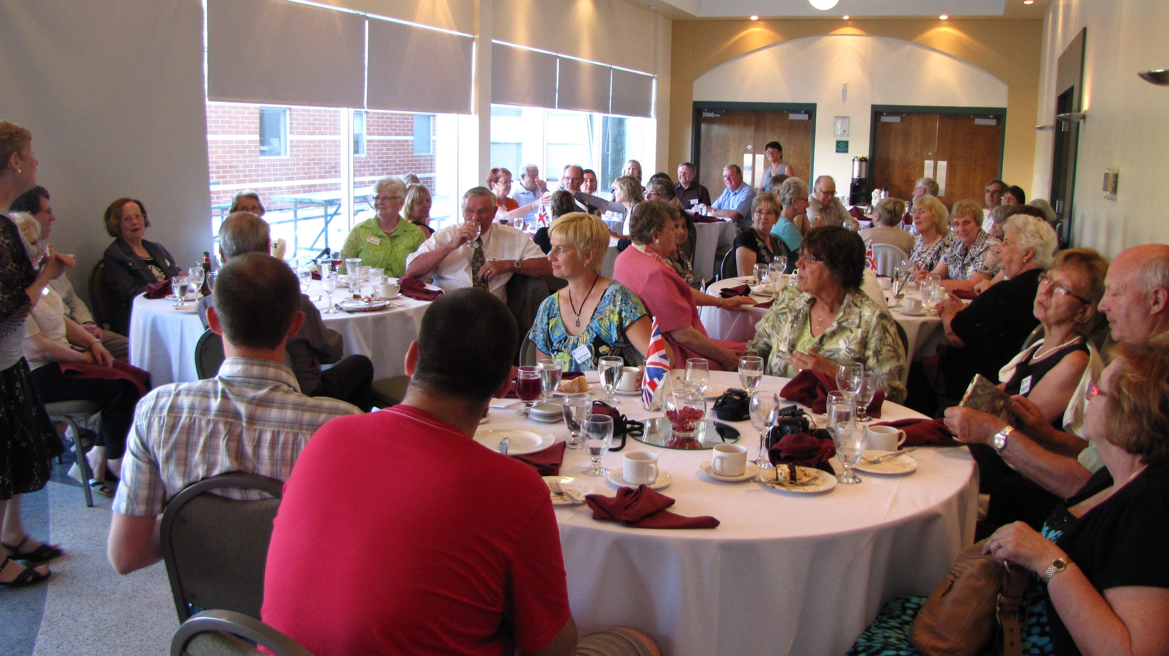
The farewell banquet

Lima, Peru, September 12-19, 2012
ED: Elizabeth Grover. We are expecting about 23 ambassadors from Lima. FF Calgary will be hosting September 5-11, and we will host the following week, September 12-19. Planning is well underway. Several more home hosts together with day hosts and dinner hosts are still required. Contact Elizabeth at 452-5299 to volunteer or for more information.

FFW Newsletter Editor/Publisher: James Kubas, Assistant Editor: Herb Schellenberg
Contact: The Friendship Force of Winnipeg; Email: friendshipforcewpg@mts.net Web site: www.friendshipforcewinnipeg.org
Friendship Force International (Headquarters): 127 Peachtree Street, Suite 501, Atlanta, Georgia 30303
Email: ffi@thefriendshipforce.org Web Site: www.thefriendshipforce.org

Exchanges

Exchange Directors are needed for 2013. Talk to Norma W., our Exchange Coordinator, or any of the members who are or have been ED’s to find out what’s involved or to volunteer.

An inbound exchange from Brazil is proposed for summer, 2013 but has yet to be confirmed. A second inbound is scheduled from Northern Illinois, USA, in September, 2013.

Our Outbound exchange will be to Trujillo and Tarapoto, Peru. This has a planned departure in October, 2013.

The Canadian Presidents' Workshop,
May 16, 2012, Quebec City

Topics Discussed included:

Liability insurance for directors and officers for all Canadian clubs. This policy would extend to EDs and
other individuals responsible for exchange events.

Initiatives to increase the number of clubs in Canada e.g. Victoria, Toronto, Atlantic Canada. .

FFI’s Health and Mobility checklist for FF Exchanges. This can be found on the FFI website and should be completed by the Host ED and sent to the Ambassador ED.

Other topics discussed were Exchange Director fees, winter exchanges, travelling to Japan, and the
Canffex website.

The next Canadian Conference will be held in Edmonton in September 2014.



.

