
The Friendly Echo
FRIENDSHIP FORCE OF WINNIPEG NEWSLETTER
Volume 12, Issue 8 October 2012

PRESIDENT’S MESSAGE
Greetings!

How time flies.... another summer has past and Fall is already here. Autumn is always a wonderful season with its many colors which we should be grateful for, as many people never get to see this.

Thank you to Herb and Shirley for hosting our last meeting in their back yard. It was a very enjoyable evening and hopefully we can do more of that in the future.

Thank you to Elizabeth, Frances and their committee for putting together a wonderful Inbound Exchange for our ambassadors from Lima, Peru. It was heartening to have so many members attend the various activities and support the Exchange. Some of the new activities were especially enjoyed by our members.

We will also be voting at this meeting for our Clubs' Outbound Exchanges for 2014. Some members voted at the August 29th meeting.

Our November 14th meeting is our Annual General Meeting. The Chairperson of the Nominating Committee is Past President, Karen Wokes.

See you in November.

In friendship
Paul Havixbeck

Happy Birthday – October Celebrants

Aruna Hall
Al Kaiser
Shirley Schellenberg
Wanda Swan
Norma Padilla

Upcoming Events

Regular meetings are planned for the remainder of 2012 at the Holiday Inn South (second Wednesday of the month).
October 10 – presentations from the latest exchanges
November 14 – Annual General Meeting
December 12 - Christmas.

Annual General Meeting (AGM)
The elected positions on the FF Winnipeg Board of Directors are President, Vice-President, Treasurer
and Secretary. All positions are open for election, however the President, Vice-President and Treasurer
are willing to let their names stand for a second term. The position of Secretary will become vacant
at the end of 2012. A nominating committee chaired by Past-President, Karen Wokes, is now seeking
nominations. If you are interested in serving in any of these positions, please contact Karen directly. At
the AGM, nominations may also be made from the floor.

The Board is also seeking Chairpersons for the Standing Committees of Activities/Fundraising and Telephone. Members who would like to volunteer for one of these positions should contact the existing executive.

Now is the time to help the club with your involvement on the Board of Directors. Speak to any Board member for more information.

2013 Exchanges
Inbound

Piracicaba, Brazil The date has not yet been set but will likely be in July. Joe Keenan has volunteered to serve as ED and Gladys Thomas as the Assistant ED.

Northern Illinois, USA. This exchange will occur in September. Jim Kubas will serve as the ED and Carol Frederickson has volunteered to be the Assistant ED.

Outbound:

Trujillo and Tarapoto, Peru. Dates have not yet been arranged, but will likely be in October. Paul Havixbeck will be the exchange director.

No details are available at this time for any of the 2013 exchanges.

2014 Exchanges
For those members who have not yet indicated preferences for outbound exchanges in 2014, the form will be available at the October dinner meeting. Norma Warecki, Exchange Coordinator, is coordinating the process. Our “wish list” for 2014 must be submitted to Atlanta by November 1, 2012.

September Inbound Exchange
Elizabeth Grover ED and Frances Lemieux Assistant ED

Members of the Friendship Force Club of Winnipeg welcomed twenty-two ambassadors from Lima Peru on September 12,2012. During the following seven days we made new friends, practiced our Spanish, and toured our beautiful city and province of Manitoba. We visited Portage La Prairie, had lunch at a local church there, stood in the middle of farmers’ fields and watched as huge machines harvested carrots and cauliflowers .We visited the Mennonite Heritage Museum in Steinbach and feasted on Mennonite food at the Livery Barn Restaurant. We toured the Ukrainian Catholic Cathedral and Grotto at Cooks Creek, then travelled north to Lower Fort Gary. We ate dinner at Eddy’s on Selkirk Avenue in Winnipeg and introduced our friends to holubtsis and perogies. Our own Voyageur, Dolores Hebert, brought to life French Canadian culture on the steps of St Boniface Cathedral. We toured the Legislative building and the Forks. We sang songs, played music and danced with our Peruvian friends. Then, on September 19th we waved farewell to our friends and made promises to keep in touch, and perhaps meet them again next year in Peru.

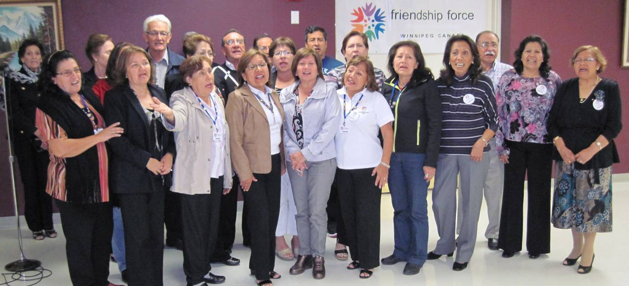


FFW Newsletter Editor/Publisher: James Kubas, Assistant Editor: Herb Schellenberg
Contact: The Friendship Force of Winnipeg; Email: friendshipforcewpg@mts.net
Web site: www.friendshipforcewinnipeg.org

Friendship Force International 127 Peachtree Street, Suite 501, Atlanta, Georgia 30303
Email: ffi@thefriendshipforce.org Web Site: www.thefriendshipforce.org

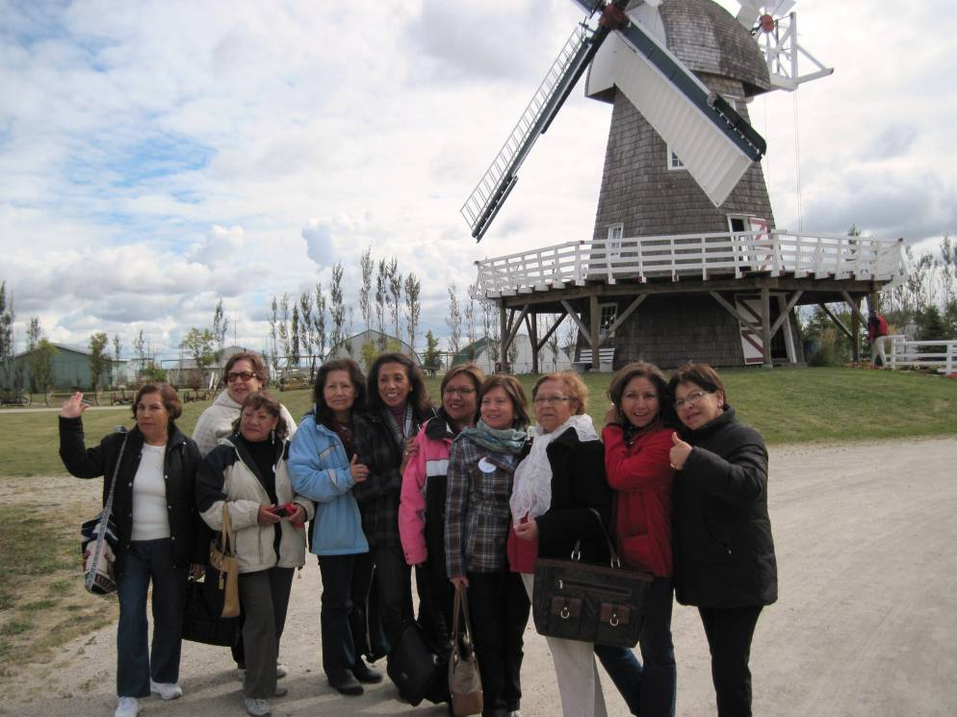

Above: Ambassadors on a cool fall day at the Mennonite Heritage Museum, Steinbach.

Below: Lima Peru ambassadors at the Welcome Potluck dinner.

Photos by Herb Schellenberg

Middle photo: FFW members wearing outdoor winter wear at the Welcome Potluck fashion show

Photos by Herb Schellenberg

