
The Friendly Echo
FRIENDSHIP FORCE OF WINNIPEG NEWSLETTER
Volume 13, Issue 1 JANUARY 2013

PRESIDENT’S MESSAGE
Dear Friends,

As we embark on a new year, I would like to wish all of you a happy, healthy and peaceful 2013.

A heartfelt thank you goes to the past Executive for their hard work and dedication over the last year. Our new Executive and Committee Chairpersons are looking forward to an eventful 2013. We welcome your input and ideas.

The plans for our Outbound Exchange to Trujillo and Tarapoto, Peru in October are well underway. Our first Inbound Exchange will be hosting Piracicaba, Brazil in early July followed by our second Inbound Exchange from Northern Illinois in mid September. Please get involved by volunteering where needed.

World Friendship Day will be celebrated on Saturday, March 2 by a Pot-Luck Dinner along with members from FF Manitoba and FF Brandon and Area. Our regular March meeting at the Holiday Inn will be cancelled.

We are still waiting to hear from Atlanta regarding our Exchanges in 2014.

In Friendship,
Paul Havixbeck

Get Well Wishes

We hope that all goes well for Al Kaiser, Bev Schultz, Val Daniel and David Judge. We wish these members all the best for a complete recovery.

Happy Birthday January Celebrants

Paul Havixbeck
Bonnie Vivier
Sachitha Attawar
Bob Kury

Membership: Renewal & Participation Reports
At the end of December we had 79 members. So far 59 members have renewed. If your membership dues for 2013 are still outstanding, you can pay them at the next meeting or mail them directly to: Val Keenan, 53 Blossom Bay Wpg. R3R 2W1 - $30/single or $50/family.
From these fees, our Club sends FFI Atlanta US$10.00 per single member and US$17.00 per family when renewing our charter which is due January 15, 2013.

Val, our Vice-President/Membership, is asking members to complete their 2012 participation reports soon.

Membership renewal forms and participation report forms will be available at our January meeting.

Thank-You
The Christmas Cheer Board has acknowledged our $300.00 donation with thanks. Thank-you to all members who contributed a tin-for-the-bin at our Christmas meeting.

Upcoming Meetings
Dinner Meetings Holiday Inn Winnipeg South, 6 PM

Meeting/Meal Charges Increase
The Holiday Inn has increased the fee for dinner by $1 per person to $25.50. Starting January 9, the meeting/meal cost will increase to $25.00 with the club making up the difference. The hotel fee includes a 15% service charge and taxes (GST & PST). The hotel also provides and sets up the room for our meeting. We were also advised that bar beverage prices would also increase but the new amounts were not indicated.

January 9 will be our first meeting in 2013, Diane Judge, our Activity/Fundraising coordinator, is planning a quiz evening.

The February meeting will on the 13^{th.}
The regular March meeting will be cancelled; replaced with our World Friendship Day Celebration on March 2.
The April meeting will be on the 10th.

World Friendship Day.
March 1, 2013 is World Friendship Day. To celebrate, we are co-hosting this event with FF Manitoba on Saturday, March 2, 2013. Invited guests are FF Brandon and area. The event will be a potluck dinner at the Sturgeon Heights Community Center, 210 Rita Street in St. James. Socializing starts at 5:30 PM and Dinner at 6:00 PM. Members, their families and friends, and prospective members are welcome.
To save on costs and the environment, please bring your dinner plate, mug, and cutlery. To decorate the tables, you are asked to bring a memento of a recent Outbound Exchange. Sign-up sheets will be available at the January and February Dinner Meetings
For more information or to help, please phone or email Charliene at 204-832-9905 or havixbec@mts.net.

Extended Absences
If you are planning to be away for an extended period and/or not available to come to the meetings, it would be most helpful if you would advise our Phone Coordinator, Dolores Tutkaluk at 204-669-4716 or dollymay510@hotmail.com. Thank-you in advance for your co-operation.

2013 Exchanges
Inbound

Piracicaba, Brazil The date has not yet been set but will likely be in early July. Joe Keenan will be the ED and Gladys Thomas will be the Assistant ED.

Northern Illinois, USA. The dates for this exchange are Wednesday, September 18 to Tuesday, September 24. Jim Kubas is the ED and Carol Frederickson is the Assistant ED. Discussions regarding organization will be starting in the very near future.

Outbound:

Trujillo and Tarapoto, Peru. The dates for this exchange are October 7 to October 21, 2013. Paul Havixbeck will be the exchange director. Paul has been looking at extending the time in Peru with optional add-ons for visiting Lima, Cuzco, Machu Picchu and Lake Titicaca. Ambassador Application forms will be available at the January meeting.

2014 Exchanges
Members have voted for their preferences for 2014 outbound exchanges. Our members’ top choices were Austria, Norway, Turkey and the Ukraine. We’ll be advised in early 2013 by FFI Atlanta of the clubs that we will be visiting in 2014.

FFI - World Conferences
The 2013 conference will be from November 22 to November 25, 2013 in New Orleans, USA.

The 2014 conference has been announced and will be held in Auckland, New Zealand in October, 2014.

Undersubscribed Canadian Outbound Exchanges
See the Canadian Friendship Force Exchange Site at http://canffex.ca/ for more information on undersubscribed exchanges being organized by other Canadian Clubs. This is a good opportunity for members to get involved in exchanges over and above those organized by our club.

FFW Newsletter Editor/Publisher: James Kubas, Assistant Editor: Herb Schellenberg
Contact: The Friendship Force of Winnipeg; Email: friendshipforcewpg@mts.net
Web site: www.friendshipforcewinnipeg.org

Friendship Force International 127 Peachtree Street, Suite 501, Atlanta, Georgia 30303
Email: ffi@thefriendshipforce.org Web Site: www.thefriendshipforce.org

Your Board of Directors – 2013
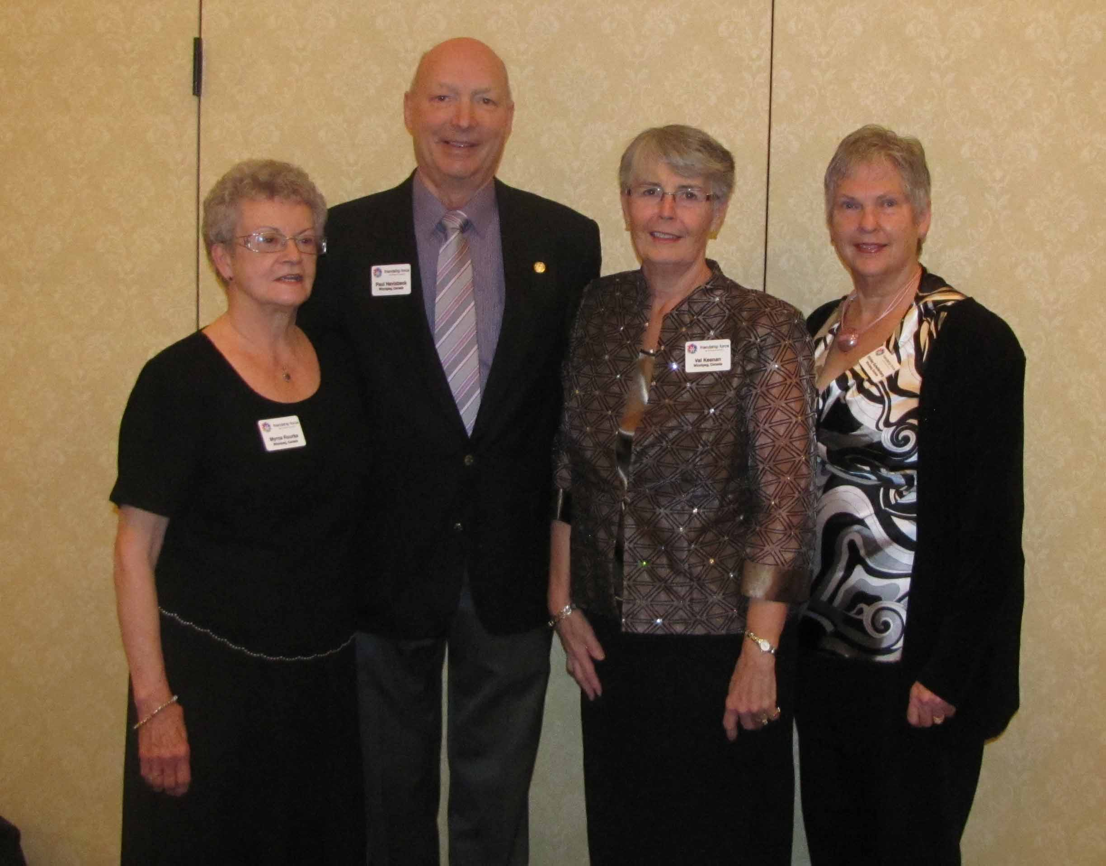

Your Executive - From Left To Right
Myrna Rourke - Secretary
Paul Havixbeck – President
Val Keenan – Vice President
Shirley Schellenberg - Treasurer

Committee Chairs
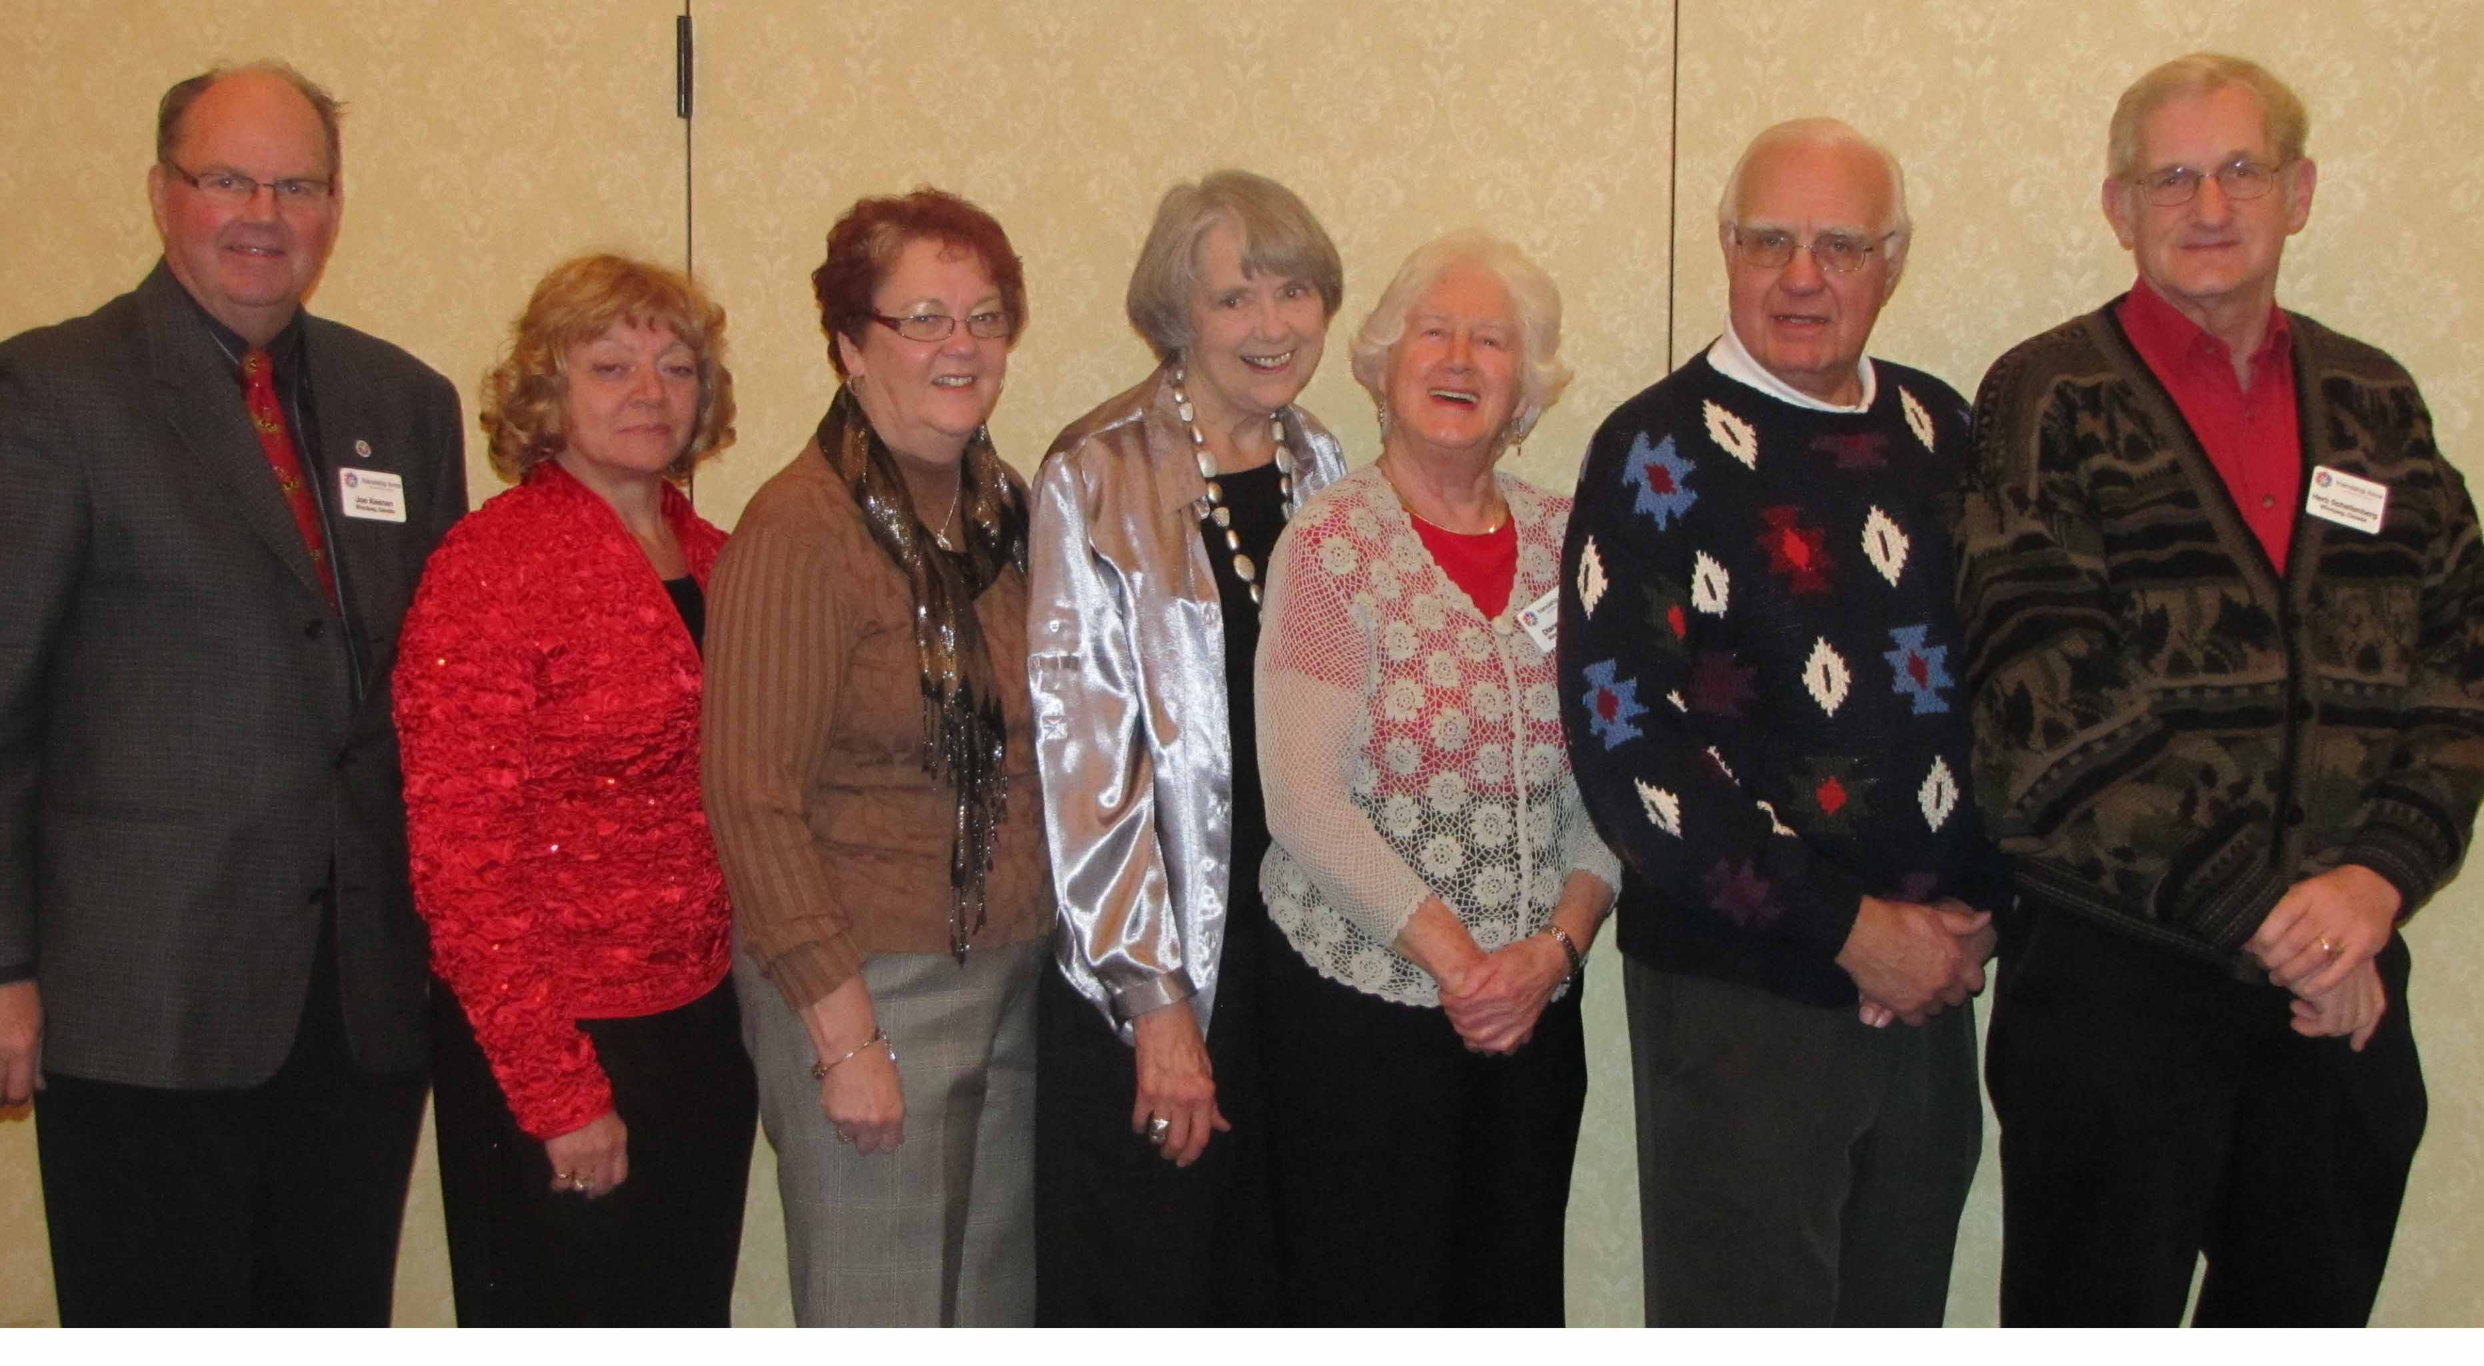

Joe Keenan – Website
Dolores Tutkaluk – Phoning
Norma Warecki – Exchange Coordinator
Karen Wokes - Past President
Diane Judge - Activities/Fundraising
Jim Kubas – Newsletter
Herb Schellenberg – Historian

Not in photo - Elizabeth Grover - Communications



.

