
The Friendly Echo
FRIENDSHIP FORCE OF WINNIPEG NEWSLETTER
Volume 13, Issue 3 March 2013



PRESIDENT’S MESSAGE
Greetings!
Thank you to all of our members for supporting our celebration of World Friendship Day on March 2. Thank you to Charliene for the great job in organizing the event and to all other members who helped out in any way. At this event, we gained a new member, Loretta Humeniuk. Welcome Loretta.

Thank you to Diane Judge for an evening of laughter and a few groans at our February meeting.

Our Outbound Exchange to Peru in October still has room for a few more ambassadors. For more information, contact me.

Please note regarding our Inbound Exchange assignment for 2014 that Comitan and Filobobos are in Mexico.

Our next Dinner meeting is on April 10 at the Holiday Inn Winnipeg South. Hope to see you there.

In Friendship
Paul Havixbeck

Member Annoucements
It is with deep regret that we announce the passing of Peter Friesen, the husband of Marlene Friesen. Our condolences and sympathy to Marlene and family.

Congratulations to Val Keenan on her informative article in the March 2013 issue of Reader's Digest More of Our Canada (www.ourcanada.ca). A copy of this article will be sent to members together with the newsletter.

Happy Birthday – March Celebrants

Gladys Spracklin
Frances Lemieux
David Judge
Jill Saunders
Herb Schellenberg

Upcoming Events
Dinner Meetings, Holiday Inn, Winnipeg South, 6 PM
A reminder that the meeting/meal cost has increased to $25.00. Our March meeting was cancelled for our World Friendship Day celebration held on March 2. A reminder that there will be no dinner meeting on March 13.

April 10 and May 8 - regular dinner meetings.
More information on these meetings will be in the next newsletter.
2013 Exchanges
Inbound
Piracicaba, Brazil. The dates for the exchange are July 5 to July 12. We have 28 ambassadors coming, ranging in ages 11 to 80. We are having our first organizational meeting on March 19th. The Friendship Force of Manitoba has agreed to help us with home hosting for this exchange. Friendship Force of Manitoba travelled to Piracicaba several years ago.

Northern Illinois, USA. The dates for this exchange are September 18 to September 24. Jim Kubas is the ED and Carol Frederickson is the Assistant ED.

Members will be asked to volunteer as Home Hosts, Day Hosts and Dinner Hosts for both inbound exchanges. Jim will soon be asking members to volunteer for the Northern Illinois inbound exchange in September as no club meetings are planned during July and August.

Outbound
Trujillo and Tarapoto, Peru. The dates for this exchange are October 7 to October 21, 2013. Paul, the ED, has been looking at extending the time in Peru with optional add-ons for visiting Lima, Cusco, Machu Picchu and Lake Titicaca.

2014 Exchanges
The 2014 Outbound Exchange to Izmir, Turkey is scheduled for one week in April. The board will be looking at options for another week of an outbound exchange. In the short term we will await the possibility for further information from FFI.

FFI - World Conferences
The 2013 conference will be from November 22 to November 25, 2013 in New Orleans, USA. Details have been emailed to FF members. Registration is now open! Go to the World Conference website to see full details and register to attend.

The 2014 conference has been announced and will be held in Auckland, New Zealand in October, 2014.

WORLD FRIENDSHIP DAY POT-LUCK DINNER

Our celebration of World Friendship day was a great success! Eighty-six people enjoyed a scrumptious feast. Those attending were members of the Friendship Force of Manitoba, the Friendship Force of Winnipeg, family members and guests. Thank you to everyone for bringing the delicious food for the buffet table. A special thank you goes to our members who helped with the set-up of the hall and the food table, assisted in the kitchen and with clean-up duties, especially Judy, Margaret, Norma, Joe, Val and Paul. Thank you to Bessie-Marie for leading us in song. A bouquet of thanks also goes to FF Manitoba members, Dallas for co-ordinating their members, Shirley for the advertising and Barbara for her Japan presentation. The room was buzzing with friendly conversation and laughter. The President of FF Manitoba announced that she looks forward to celebrating World Friendship day next year with us.

Please call or email Charliene if you left behind a paprika coloured bath towel used to keep your food warm.
(204.832.9905 or havixbec@mts.net)

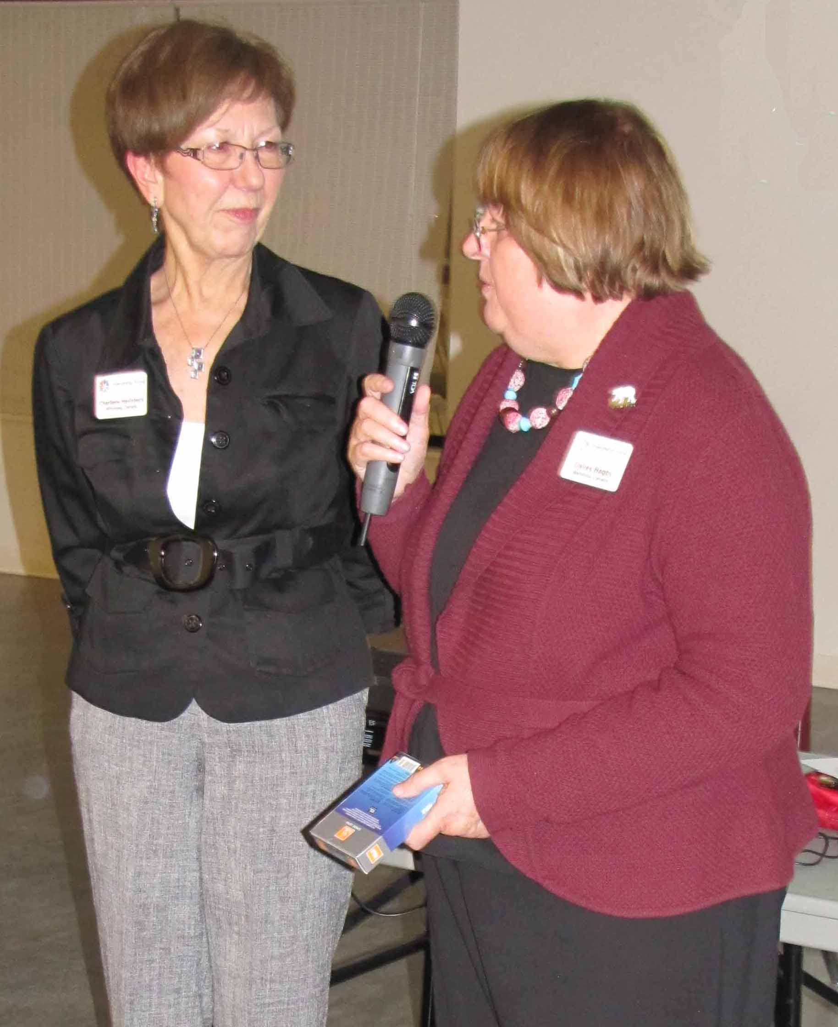

Dallas Bagsby making a presentation to Charliene Havixbeck in recognition of her work in organizing WFD.


Contact: The Friendship Force of Winnipeg; Email: friendshipforcewpg@mts.net
Web site: www.friendshipforcewinnipeg.org
FFW Newsletter Editor/Publisher: James Kubas, Assistant Editor: Herb Schellenberg

Friendship Force International 127 Peachtree Street, Suite 501, Atlanta, Georgia 30303
Email: ffi@thefriendshipforce.org Web Site: www.thefriendshipforce.org
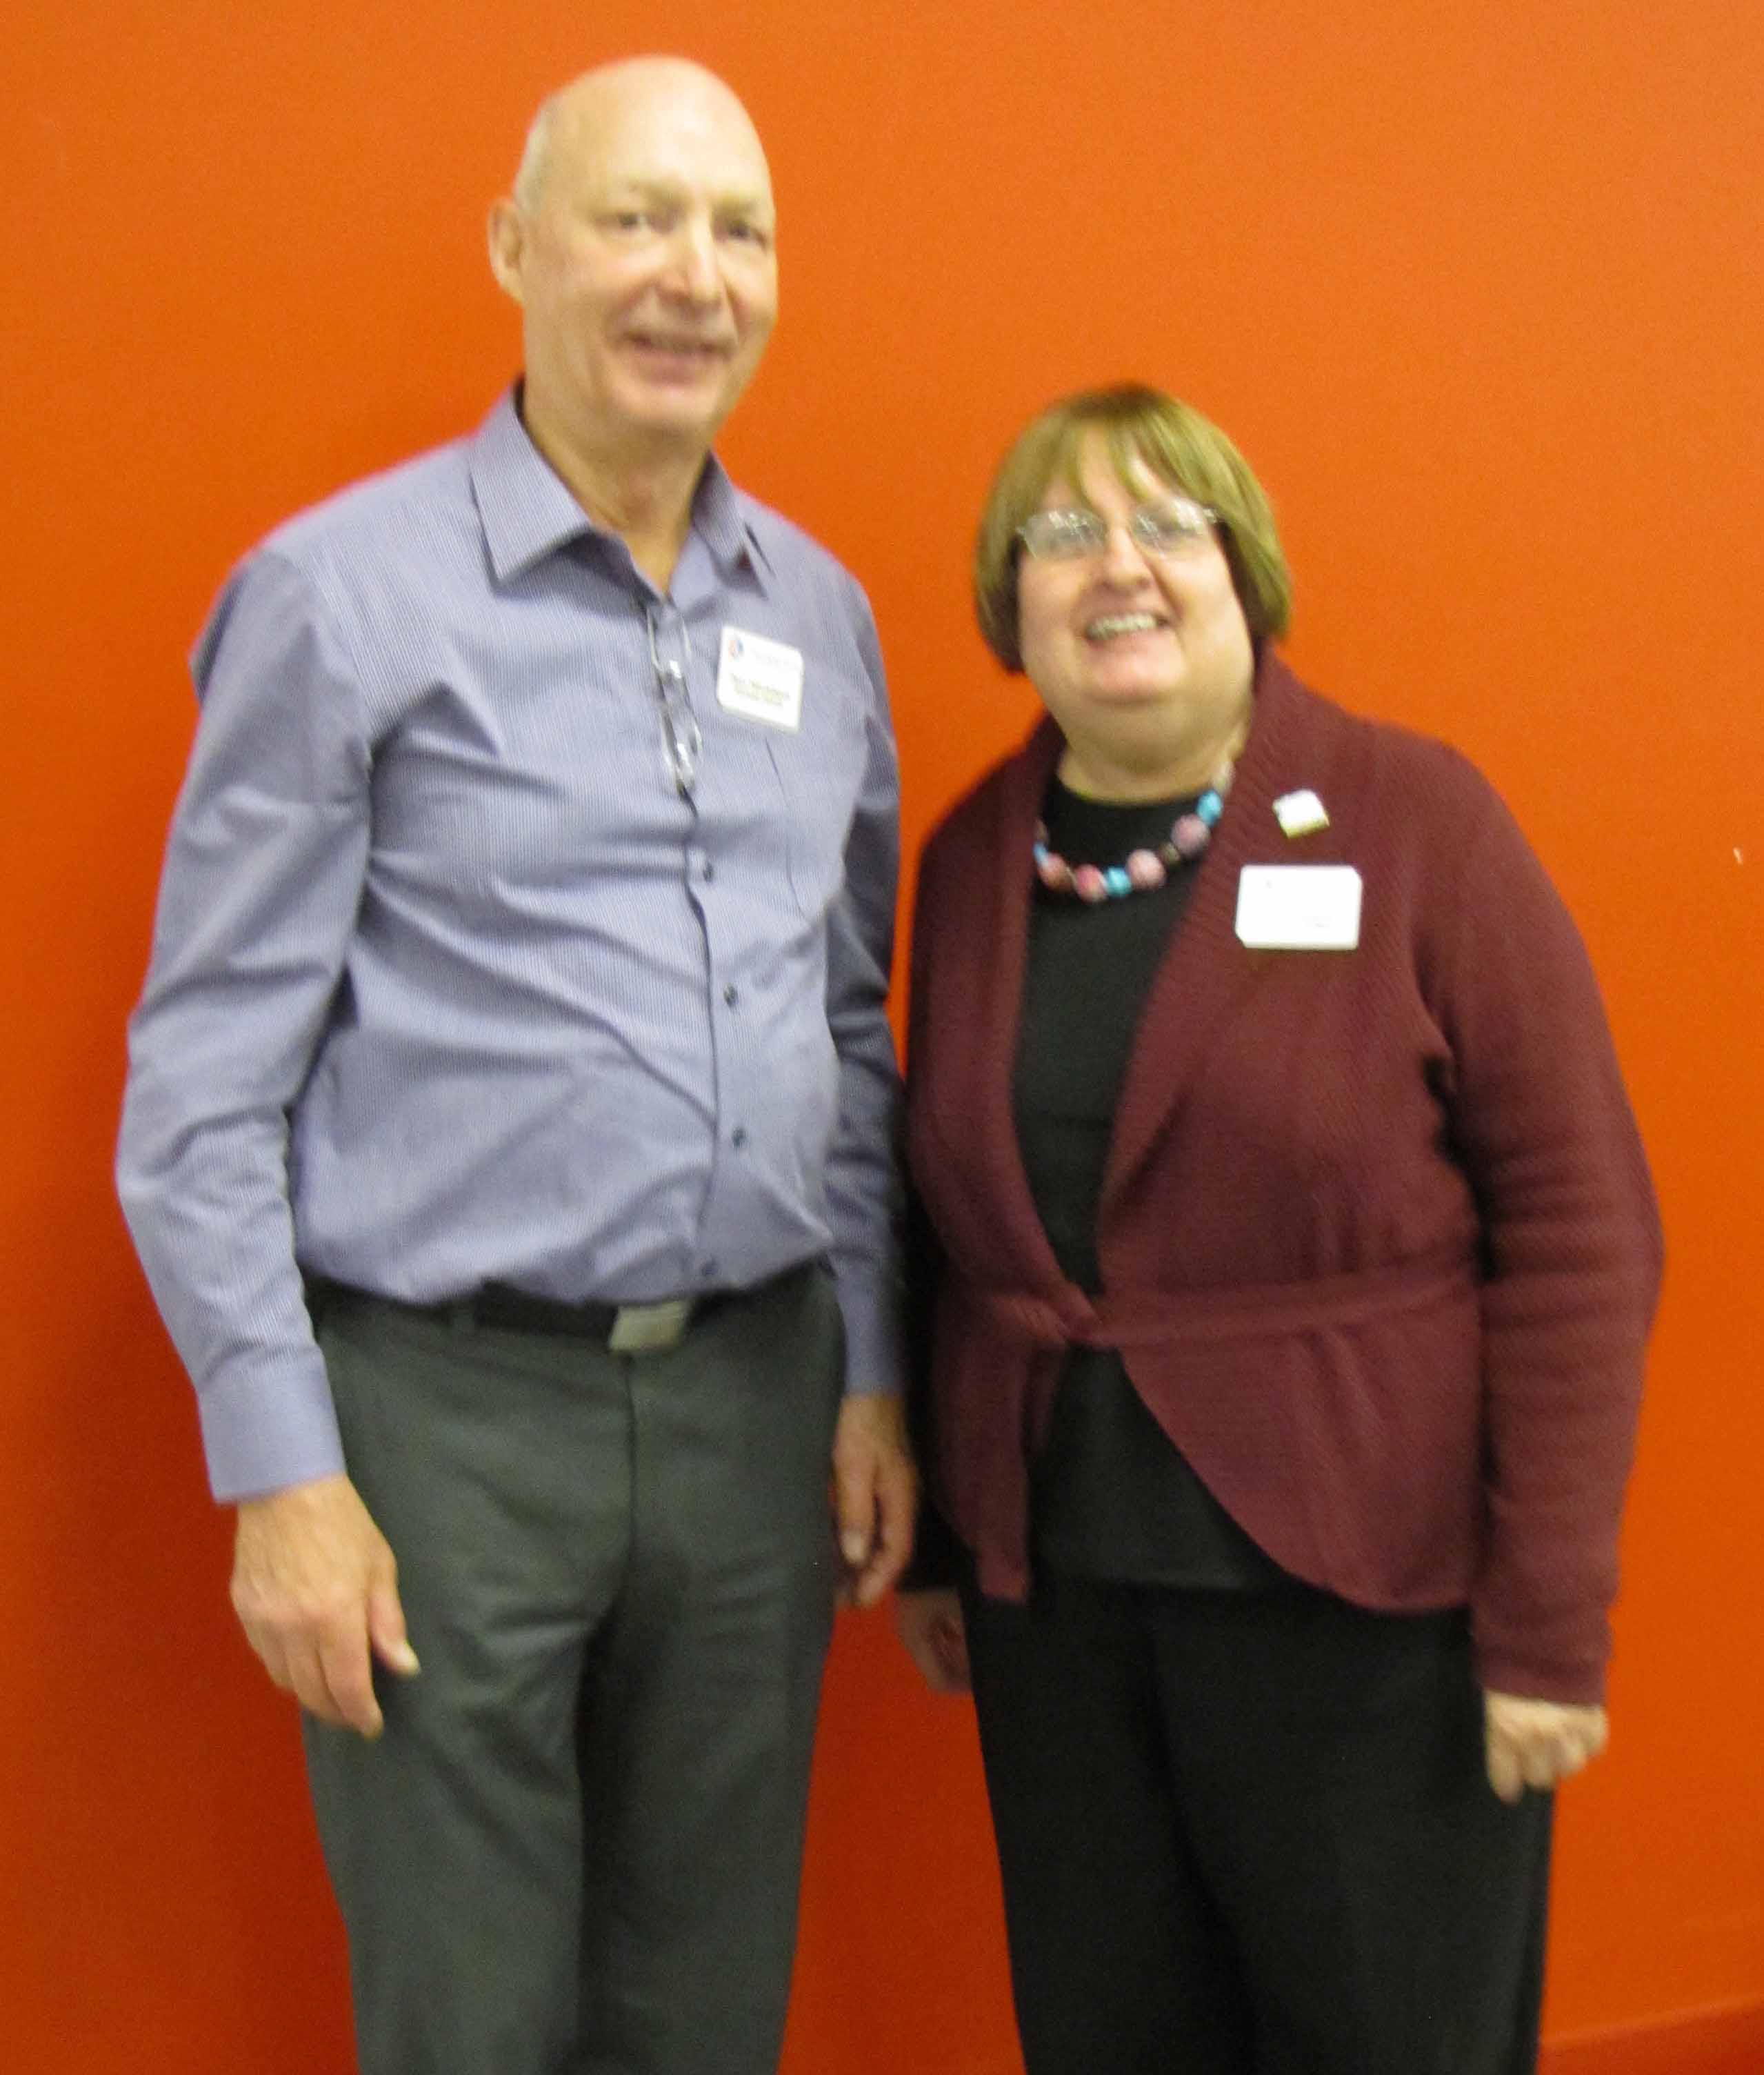

The FF Presidents: Paul Havixbeck & Dallas Bagsby

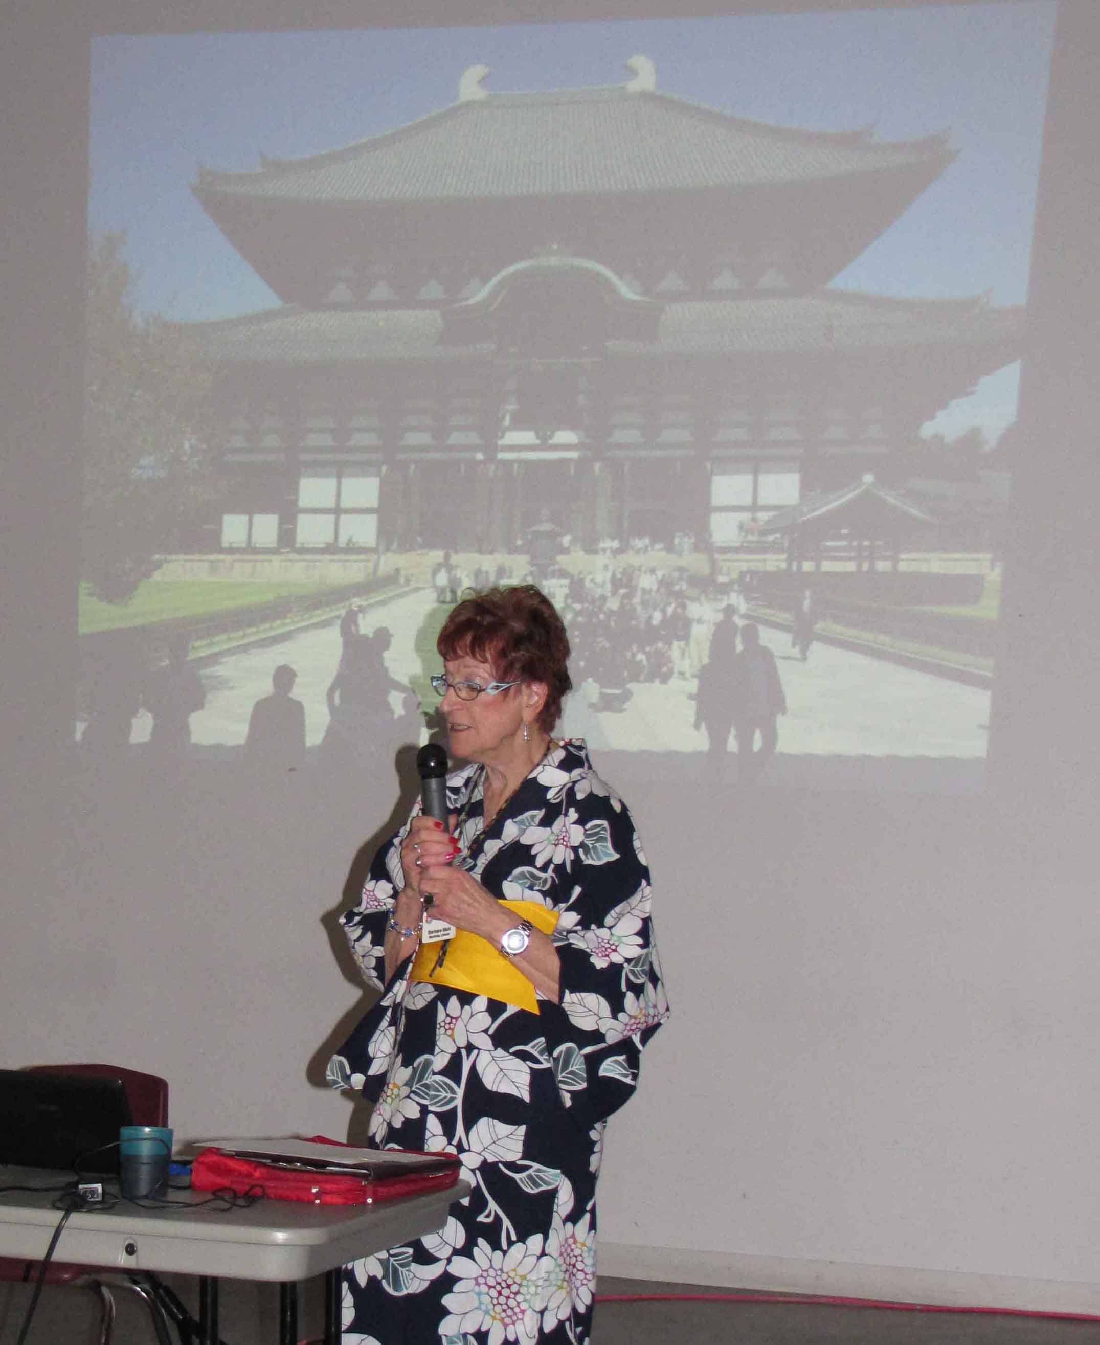

Barbara Main making a slide presentation on FF Manitoba's exchange to Japan in October, 2012. The kimono Barbara was wearing added an authenic touch to a most enjoyable presentation.

