
The Friendly Echo
FRIENDSHIP FORCE OF WINNIPEG NEWSLETTER
Volume 13, Issue 8 November, 2013

PRESIDENT’S MESSAGE

Greetings!

A big thank you to Karen W for chairing the dinner meeting last month while a number of us were away on a wonderful adventure in Peru.

We had an exciting time in Peru, not only with the Exchanges, but also with our add-on excursion. Target Peru, our travel agent in Cusco, provided our group with excellent service. They were there to help us with any problems on our domestic flights (we did have a few) and set up a wonderful tour of Cusco, Machu Picchu, Puno and Lake Titicaca. Their attention to detail and professionalism made that week very special for all of us.

November is our Annual General Meeting, at which time you will hear short reports from the various committees who have been working hard all year. Thank you to Elizabeth and the nominating committee for obtaining a full slate of nominees for the elected positions. There is always a need for volunteers to chair or assist with the various committees.

We are in need of Exchange Directors for 2014 for our Inbound Exchange from Saitama, Japan and our Outbound Exchange. Please consider taking on the role. There are many members who would be willing to assist you in organizing an Exchange.

Plan to attend our Christmas Party on December 11 as it is always a festive occasion. Once again, the Board has decided to collect a ”Tin for the Bin" at the December dinner meeting.

In Friendship
Paul Havixbeck

Happy Birthday – November Celebrants

Adele McMurtrie
Janice Desautels
Jim McMurtrie
Edna Pohl
Nancy Clendenan
Mary McQueen
Lovern Daniels

Thank-you

FF Winnipeg thanks FF Northern Illinois for their donation of $100 made to The Trans-Canada Trail in appreciation of our hosting their club this past September.

FF Winnipeg thanks Target Peru, the club's travel agent for the recent exchange to Peru for their superior service and personal attention which contributed greatly to an enjoyable, professional and well-run tour.

Announcements
FF Winnipeg extends its condolences and sympathy to Lorraine Franz, Gladys Thomas and Dolores Tutkaluk who all recently experienced the loss of a close family member.

Our thoughts are with Allan and Karen Wokes for Allan's on-going medical struggles.

We will be missing one of our long time members, Wanda Swan who has recently moved to Ottawa. Our best wishes to Wanda on her move and we hope to keep in touch.

The Board has proposed a $300.00 donation to the Christmas Cheer Board. approval from the membership will be sought at the November meeting.

Upcoming Meetings
The Annual General Meeting will be on November 13 at 6:00PM at the Holiday Inn South for the election of officers and the annual reports from the committee chairs. Note: the meeting will be held on the 2nd floor.

The elected officers of the club are President, Vice-President, Secretary and Treasurer and all positions are to be filled. The Nominating Committee has proposed nominees for each of the elected positions. In addition,
nominations can also be made from the floor at the AGM.

Regular dinner meetings at the Holiday Inn Winnipeg South are planned for December 11, 2013, January 8th and February 12th, 2014. Mark your calendars.

Our December meeting will be a Christmas celebration and our members are encouraged to come "dressed-up" for the season. We will feature a bake sale. Please bring along a cake, pie or cookies etc. suitably wrapped and priced; an attached printed recipe would be much appreciated. The evening will close with our usual candle-lit sing-along of familiar carols Members are asked to bring a "Tin for The Bin" to the meeting which will be donated to the Cheer Board. Please make sure the donated items are not past its best before date.

2013 Exchanges

Our Outbound Exchanges to Trujillo and Tarapoto, Peru were enjoyed by the following members of our club: Paul & Charliene, Joe & Val K, Terry & Myrna, Adele, Gladys T, Norma P, Brenda and Germana. The Exchanges provided our ambassadors and those ambassadors from other Canadian clubs and one American club an opportunity to renew friendships and make new ones. We had a very good group of FF members who were positive, open-minded and willing to "go with the flow". Our activities included very lively Welcome and Farewell Parties featuring traditional dancing and singing performances by professional groups as well as by their own members. Other activities were city tours, meetings with regional government officials, visits to archaeological sites, a Paso Horse Show, visits to a coconut factory, a cacao farm, women's cooperatives producing chocolate and ceramics, an overnight stay at a lodge in the jungle, cooling off at a waterfall, and a boat trip. A big thank you goes out to Liz from Toronto, who suggested our farewell performance. We sang along with the music and lyrics of "Hay un amigo en mi", which was a big hit, starting a chain reaction of hugs and kisses all around bidding a fond farewell. What memorable Exchanges! Friendship Force can truly "change the way you see the world".

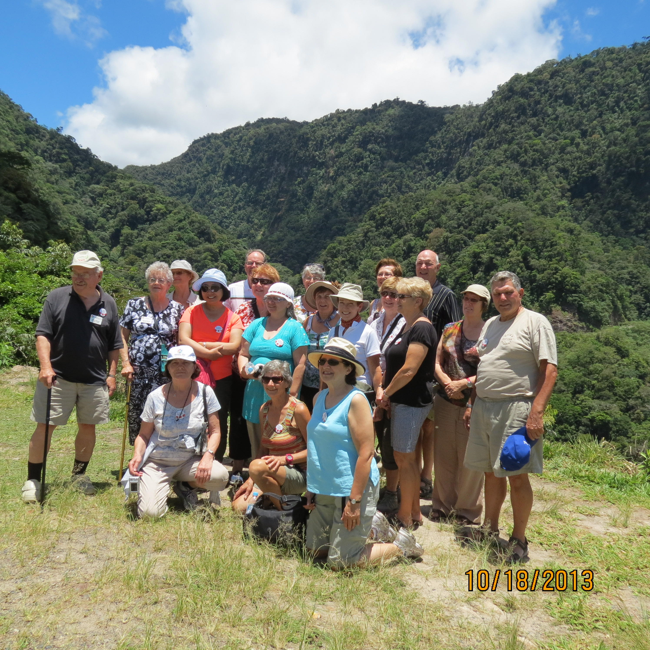
The Outbound Ambassadors near Tarapoto

Contact: The Friendship Force of Winnipeg; Email: friendshipforcewpg@mts.net
Web site: www.friendshipforcewinnipeg.org
FFW Newsletter Editor/Publisher: James Kubas, Assistant Editor: Herb Schellenberg

Friendship Force International 127 Peachtree Street, Suite 501, Atlanta, Georgia 30303
Email: ffi@thefriendshipforce.org Web Site: www.thefriendshipforce.org

2014 Exchanges

The 2014 Outbound Exchange to Izmir, Turkey is scheduled for one week in April.

We will be hosting two inbound exchanges in 2014. Tentative dates for these exchanges are FF Comitan/FF Filibobos, Mexico in July and FF Saitama, Japan from September 3rd to the 9th.

For each of the 2014 exchanges, our club will require an Exchange Director and an Assistant Exchange Director.
It's time to consider becoming actively involved with these exchanges. Don't leave it for someone else!

2015 Exchanges

Our requests for our 2015 outbound exchanges have been submitted. Austria, Northwestern USA and Indonesia are the places we requested for 2015. This was based on a survey of our members.

FFI News

The 2013 World Conference will be from November 22 to November 25, 2013 in New Orleans, USA. There will be a good representation of members from our club in attendance. Val K. will be presenting her article "Forging New Friendships" which was published in the magazine More of Our Canada.

The 2014 conference will be held in Auckland, New Zealand from October 14 to 16, 2014. Registration will begin in early 2014.

The 2015 World Conference has been announced. It is scheduled to take place in Vancouver, Canada from September 11 to 14, 2015.


Paul H. has forwarded several emails to all members which outline some of the exchanges available to FF members. Check Canffex.ca for undersubscribed exchanges from Canadian Clubs and the World of Friends Catalogue for themed and other exchanges.

