The Friendship Force of Huntsville, Alabama

Visits Winnipeg, May 30th to June 6, 2007

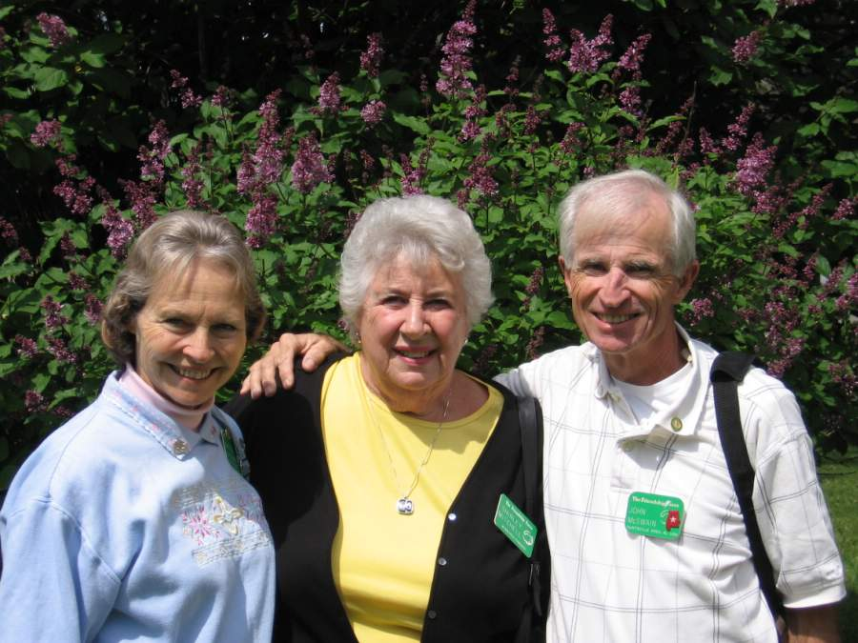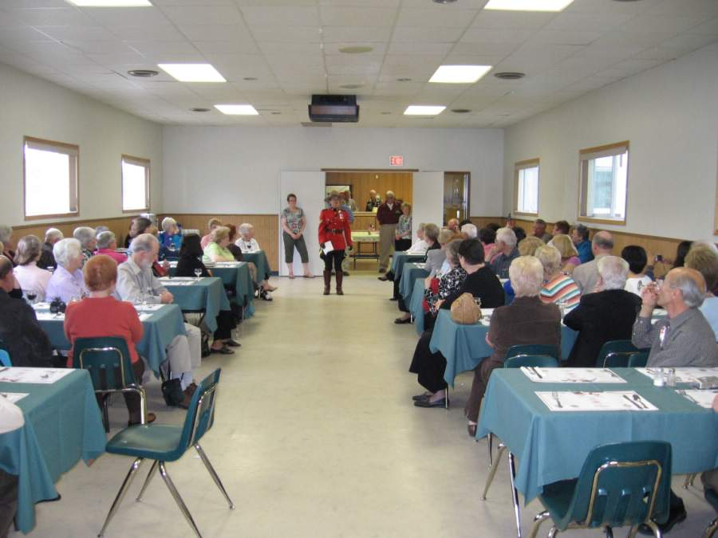

Winnipeg ED Shirley Mitchell with RCMP Sargeant Joanne Keeping at

Huntsville EDS John and Marjie McSwain the Welcome Pot Luck Dinner

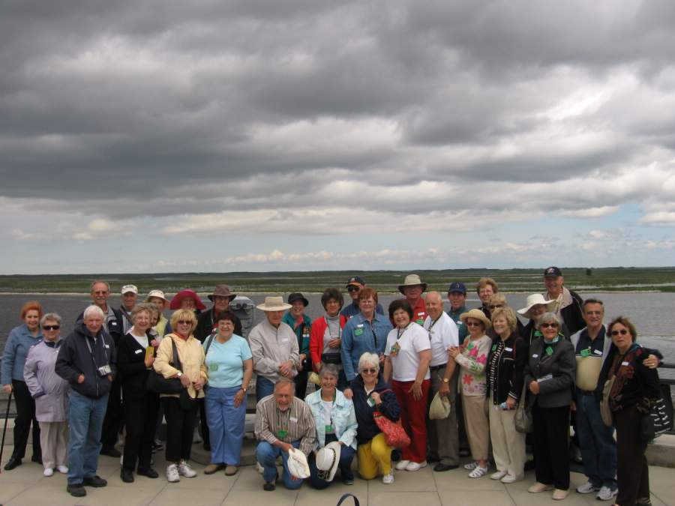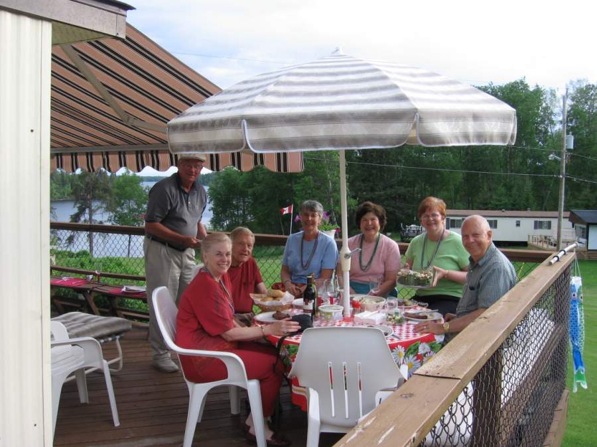

Ambassadors and Hosts at Oak Hammock Relaxing on a free day at the lake

Marsh Wildlife Management Area

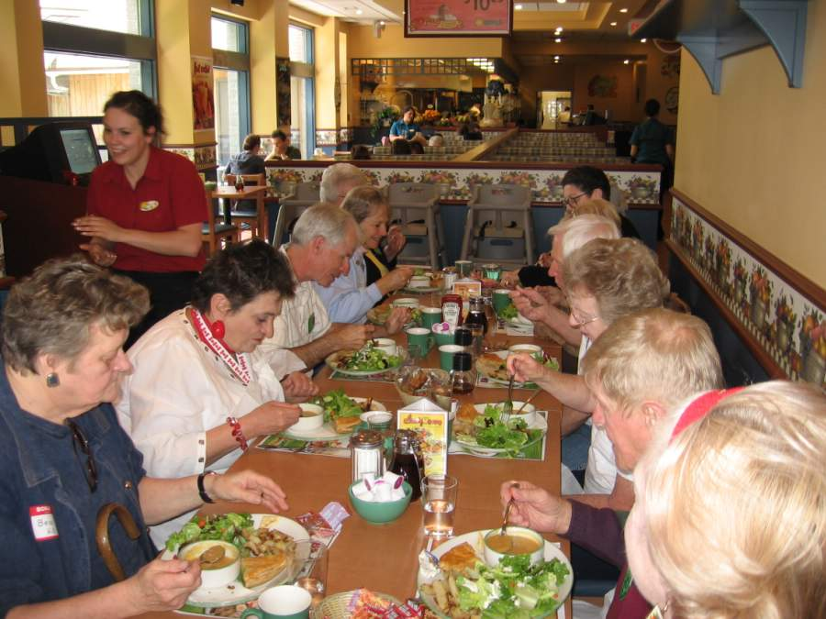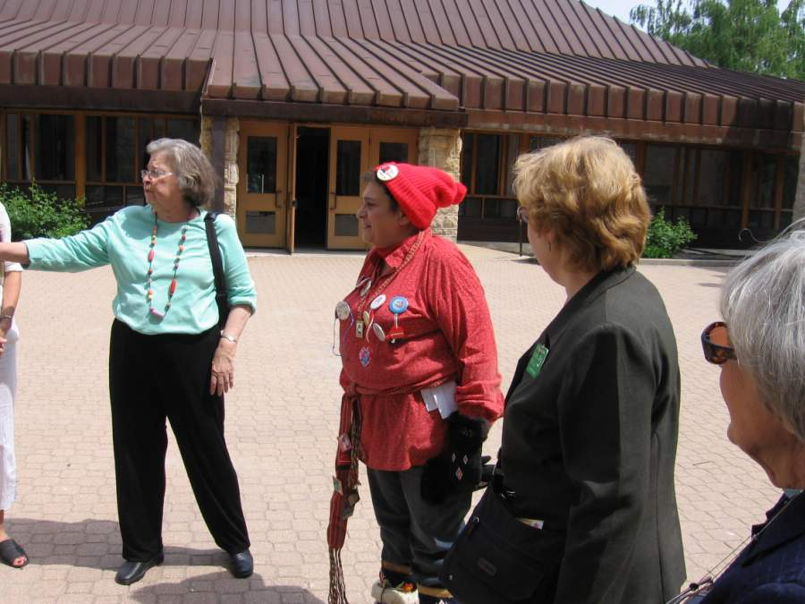

French Canadian Lunch at Cora’s Voyageur Delores at St Boniface Cathedral

