
The Friendly Echo
FRIENDSHIP FORCE OF WINNIPEG NEWSLETTER
Volume 13, Issue 8 October, 2013

PRESIDENT’S MESSAGE

Greetings!
The October 9th Dinner Meeting will be chaired by our Past President, Karen Wokes. Thank-you, Karen. Charliene and I along with 10 other members from our club will be on an Exchange to Peru.

Thank you to Herb and Shirley for hosting our last meeting in their back yard, and to Val for chairing the meeting. By all accounts it was a very enjoyable evening.

Thank you to Jim, Carol and their committee for putting together a wonderful Inbound Exchange for our ambassadors from Northern Illinois. Everyone seemed to enjoy the various activities showcasing Winnipeg's past and present.

Welcome to our new members Tom McDermott, Germana Stangherlin and Brenda Koch-Schulte. Both Germana and Brenda are joining us on our exchange to Peru.

Our Outbound Exchange requests, as voted by the members for 2015 which have been submitted to FFI are Austria, North Western USA and Indonesia. Twenty-one members indicated an interest in a domestic exchange. If you are willing to help organize a domestic exchange, contact Norma W or any Board member.

Our November 13th meeting is our Annual General Meeting. The Chairperson of the Nominating Committee is Elizabeth. Please consider being a member of the Board to ensure that our club remains strong and vibrant.

In Friendship
Paul Havixbeck

Happy Birthday – October Celebrants

Aruna Hall
Al Kaiser
Shirley Schellenberg
Wanda Swan
Norma Padilla

Member Annoucements
Val Keenan, our Vice president and membership coordinator, will be making a presentation at the FFI world conference in November, 2013 in New Orleans.

Val will be presenting her article "Forging New Friendships" which was published by Reader's Digest in their magazine Our Canada. This article was distributed with the March 2013 Issue of The Friendly Echo.
Congratulations Val.

Membership Updates - please advise Val Keenan of changes to your email address or your phone number or home address. If we have your current address (email or otherwise), you always get the next issue of The Friendly Echo and other club information and announcements.

Upcoming Meetings

Next Meeting: October 9, 2013 6 PM at Holiday Inn Winnipeg South. Our activity for the October 9th dinner meeting will be a mini (some of our members will be on the Exchange to Peru) recipe swap of some of the delicious dishes that members bring to the Potlucks.
Bring along your recipe, plus pen and paper to write down the recipes as they are read out. Hope this will be of interest to both male and female cooks and also encourage those who don't cook to maybe try their hand at some of the more simple dishes.

Regular dinner meetings at the Holiday Inn Winnipeg South for the rest of 2013 are planned on November 13, and December 11.

Election of Officers
It is once again time to think about next year's elected executive. The election of officers will be held at the Annual General Meeting in November. The elected officers of the club are President, Vice-President, Secretary and Treasurer. Candidates for elective club offices are elected for a term of one year but may continue for one more year in that office. The officers of President, Vice-President and Treasurer have all served 2 years. Members interested in letting their name stand for any of the elected positions are asked to contact Elizabeth G. who is chairing the Nominating Committee or other committee members: Herb S., Karen W., Dolores T., and Norma W. You can talk to any of these committee members to find out what is involved in becoming a board member and how you can help make our club a better one. Your editor has been a board member as an appointed committee chair since he joined FFW two years ago. I found it a rewarding experience and an excellent way to develop and strengthen friendships. With the help of other members, the tasks are never as daunting as they may appear.

Nominations can also be made from the floor at the AGM.

2013 Exchanges

Northern Illinois, USA - September 18 to September 24. Jim Kubas was the ED and Carol Frederickson was the Assistant ED. We hosted 14 incoming ambassadors; 10 from FF Northern Illinois, 2 from FF Greater Orlando, Florida and 2 from Cedar Rapids, Iowa.

A total of 55 club members participated in one or more of the 12 planned activities during the exchange. The average participation per activity was 30 (16 FFW members and 14 ambassadors). The activities were planned to showcase the cultural diversity and history of Winnipeg and environment. Two free days (Saturday and Sunday) were provided to give the ambassadors an opportunity to become better acquainted with their home hosts, and to enjoy and learn more about our part of the world. Two of our home host families hosted ambassadors that they had met on previous exchanges.
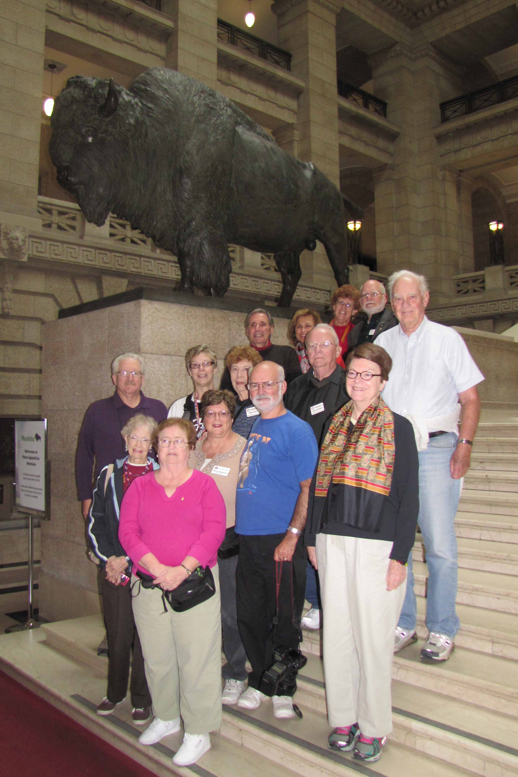
Our inbound Ambassadors at the Manitoba Legislature on the grand staircase beside "Toba" the Bison

Contact: The Friendship Force of Winnipeg; Email: friendshipforcewpg@mts.net
Web site: www.friendshipforcewinnipeg.org
FFW Newsletter Editor/Publisher: James Kubas, Assistant Editor: Herb Schellenberg

Friendship Force International 127 Peachtree Street, Suite 501, Atlanta, Georgia 30303
Email: ffi@thefriendshipforce.org Web Site: www.thefriendshipforce.org

Outbound

Trujillo and Tarapoto, Peru. ED Paul Havixbeck; Assistant ED, Lorraine Franz . Paul and other outbound ambassadors will leave for Peru on October 5. The dates for this exchange are October 7 to October 21, 2013. There are 21 ambassadors for this exchange: 10 from our club, 5 from FF Manitoba, 5 from other clubs in Canada and 1 from a club in USA. The exchange will be extended with visits to Cusco, Machu Picchu, Lake Titicaca and Lima. Bon Voyage!

2014 Exchanges

The 2014 Outbound Exchange to Izmir, Turkey is scheduled for one week in April.

We will be hosting two inbound exchanges in 2014. Tentative dates for these exchanges are FF Comitan/FF Filibobos, Mexico in July and FF Saitama, Japan from September 3rd to the 9th.

For each of the 2014 exchanges, our club will require an Exchange Director and an Assistant Exchange Director.
It's time to consider becoming actively involved with these exchanges. Don't leave it for someone else!

2015 Exchanges

The deadline for submitting our requests for our outbound exchanges for 2015 is November 1, 2013. Members who responded to the survey picked (in order) Austria, Northwestern USA, Indonesia and Albania as places to be requested for our 2015 outbound exchanges.

FFI News

The 2013 conference will be from November 22 to November 25, 2013 in New Orleans, USA. This will be the best attended FFI world conference.

FFI is having another Friendship Force On-line Auction You can bid on hospitality and cultural opportunities. Proceeds benefit the Legacy Fund to support expanding the mission of the Friendship Force around the globe. Bidding will close on November 15, 2013 at 12:01 pm North American EST. Go to the FFI website for details.



Contact: The Friendship Force of Winnipeg; Email: friendshipforcewpg@mts.net
Web site: www.friendshipforcewinnipeg.org
FFW Newsletter Editor/Publisher: James Kubas, Assistant Editor: Herb Schellenberg

Friendship Force International 127 Peachtree Street, Suite 501, Atlanta, Georgia 30303
Email: ffi@thefriendshipforce.org Web Site: www.thefriendshipforce.org

