
The Friendly Echo
FRIENDSHIP FORCE OF WINNIPEG NEWSLETTER
Volume 13, Issue 7 September 2013

PRESIDENT’S MESSAGE

Greetings!
Thank you to Dolores T. for graciously hosting our June picnic again and to the Judges and Margaret for organizing the food and the mini garage sale. From all reports it was a delightful evening.

Thank you to Joe K. and his committee for organizing a wonderful Exchange for the group from Piracicaba, Brazil, and also to all of our members for supporting the activities during the week.

I hope everyone has had a good summer. As September approaches, we will be busy with our ambassadors from Northern Illinois. Jim K and his committee have been working hard organizing the Exchange activities. Let’s all try to get involved in one way or another, make new friends and have some fun.

It is also time to start thinking about our exchange requests for 2015 as our “Wish List” has to be submitted to FFI by November 1, 2013. At the May and June meetings, members have suggested various places to visit. From these suggestions a list of choices has been compiled. Forms will be available at our August meeting with a list of destinations that members can choose.

In Friendship
Paul Havixbeck

Happy Birthday – Summer Celebrants

July August
Margaret Birk Alma Vincent
Dolores Hébert Irv Reschke
Rick Klimack Carol Frederickson
Martha Klimack Lorry Lesyk
Terry Hercus


September
Beatriz Serpa
Joan Ostermann
Charliene Havixbeck
Larry Franz
Diane Kubas
Valerie Clancy

Thank-you

A very heartfelt thank-you to all the FF members who sent greetings and get well wishes since my heart valve surgery July 11. Sincerely Al Wokes.

A big thank-you to all those who came out and supported our June picnic. What an array of treasures lined the deck for the mini-garage sale - baking, garden produce, plant cutting books, pictures, knick-knacks and "conversation pieces" - shall we do it again next year? Special thanks to Dolores Tutkaluk for providing the venue and letting us have the run of her kitchen, to my reliable co-worker Margaret Birk and to Dave who cheerfully pitches in where and when needed. Collective thanks to our roving troubadour and all who helped in any way whatsoever. Members of the Friendship Force truly are special people. Diane Judge - Activities Coordinator

Upcoming Meetings

August 28, - 5:30 PM - Picnic meeting in the Schellenberg's backyard.
A club get-together is planned for Wednesday, August 28th at Herb and Shirley Schellenberg's place, 583 Harstone Rd. in Charleswood at 5:30PM; phone 204-837-3347. As in 2012, this meeting is in lieu of our usual September dinner meeting due to an incoming exchange. Everyone should bring finger food (something that can be eaten without a knife and fork) - appetizers, veggies, crackers and cheese, etc. (a chance to try a new recipe) or a dessert. The idea is to keep our gathering and eats as simple as possible. Bring your own beverage and lawn chairs. Disposable plates, napkins coffee, tea and water will be available. Let's hope for good weather.

September 11 dinner meeting at the Holiday Inn has been changed to September 18 (at the Holiday Inn). This will be the Welcome Banquet for the FF Northern Illinois Club inbound exchange. Please mark your calendars and the activity sheet you'll be receiving.

Regular dinner meetings at the Holiday Inn Winnipeg South are planned for the rest of 2013 on October 9, November 13, and December 11.

Election of Officers
It is once again time to think about next year's elected executive. The election of officers will be held at the Annual General Meeting in November. The elected officers of the club are President, Vice-President, Secretary and Treasurer. Candidates for elective club offices are elected for a term of one year but may continue for one more year in that office. The officers of President, Vice-President and Treasurer have all served 2 years. Members interested in letting their name stand for any of the elected positions are asked to contact Elizabeth G. who will chair the Nominating Committee.
2013 Exchanges

Inbound
Piracicaba, Brazil: Our club welcomed 23 ambassadors from July 4th to July 11th after which they left for Milwaukee for another week to complete their North American exchanges.

Joe Keenan was the ED and Gladys Thomas was the Assistant ED. it was a fun week filled with interesting and unique activities. We took in Scheutzenfest in the Little Britain area (near Lockport) which is based on a marksmen shooting event that is traditional in Germany. We had a bus trip to Southern Manitoba where the highlight was a visit to Neuburgthal, a designated historic site, to tour a Mennonite village and its unique housebarns. The farewell banquet was held at the Hunt's Country Roadhouse, north of Petersfield, where one of the highlights was a huge nostalgia collection of 40's, 50's and 60's memorabilia.

The Welcome Banquet - July 4th
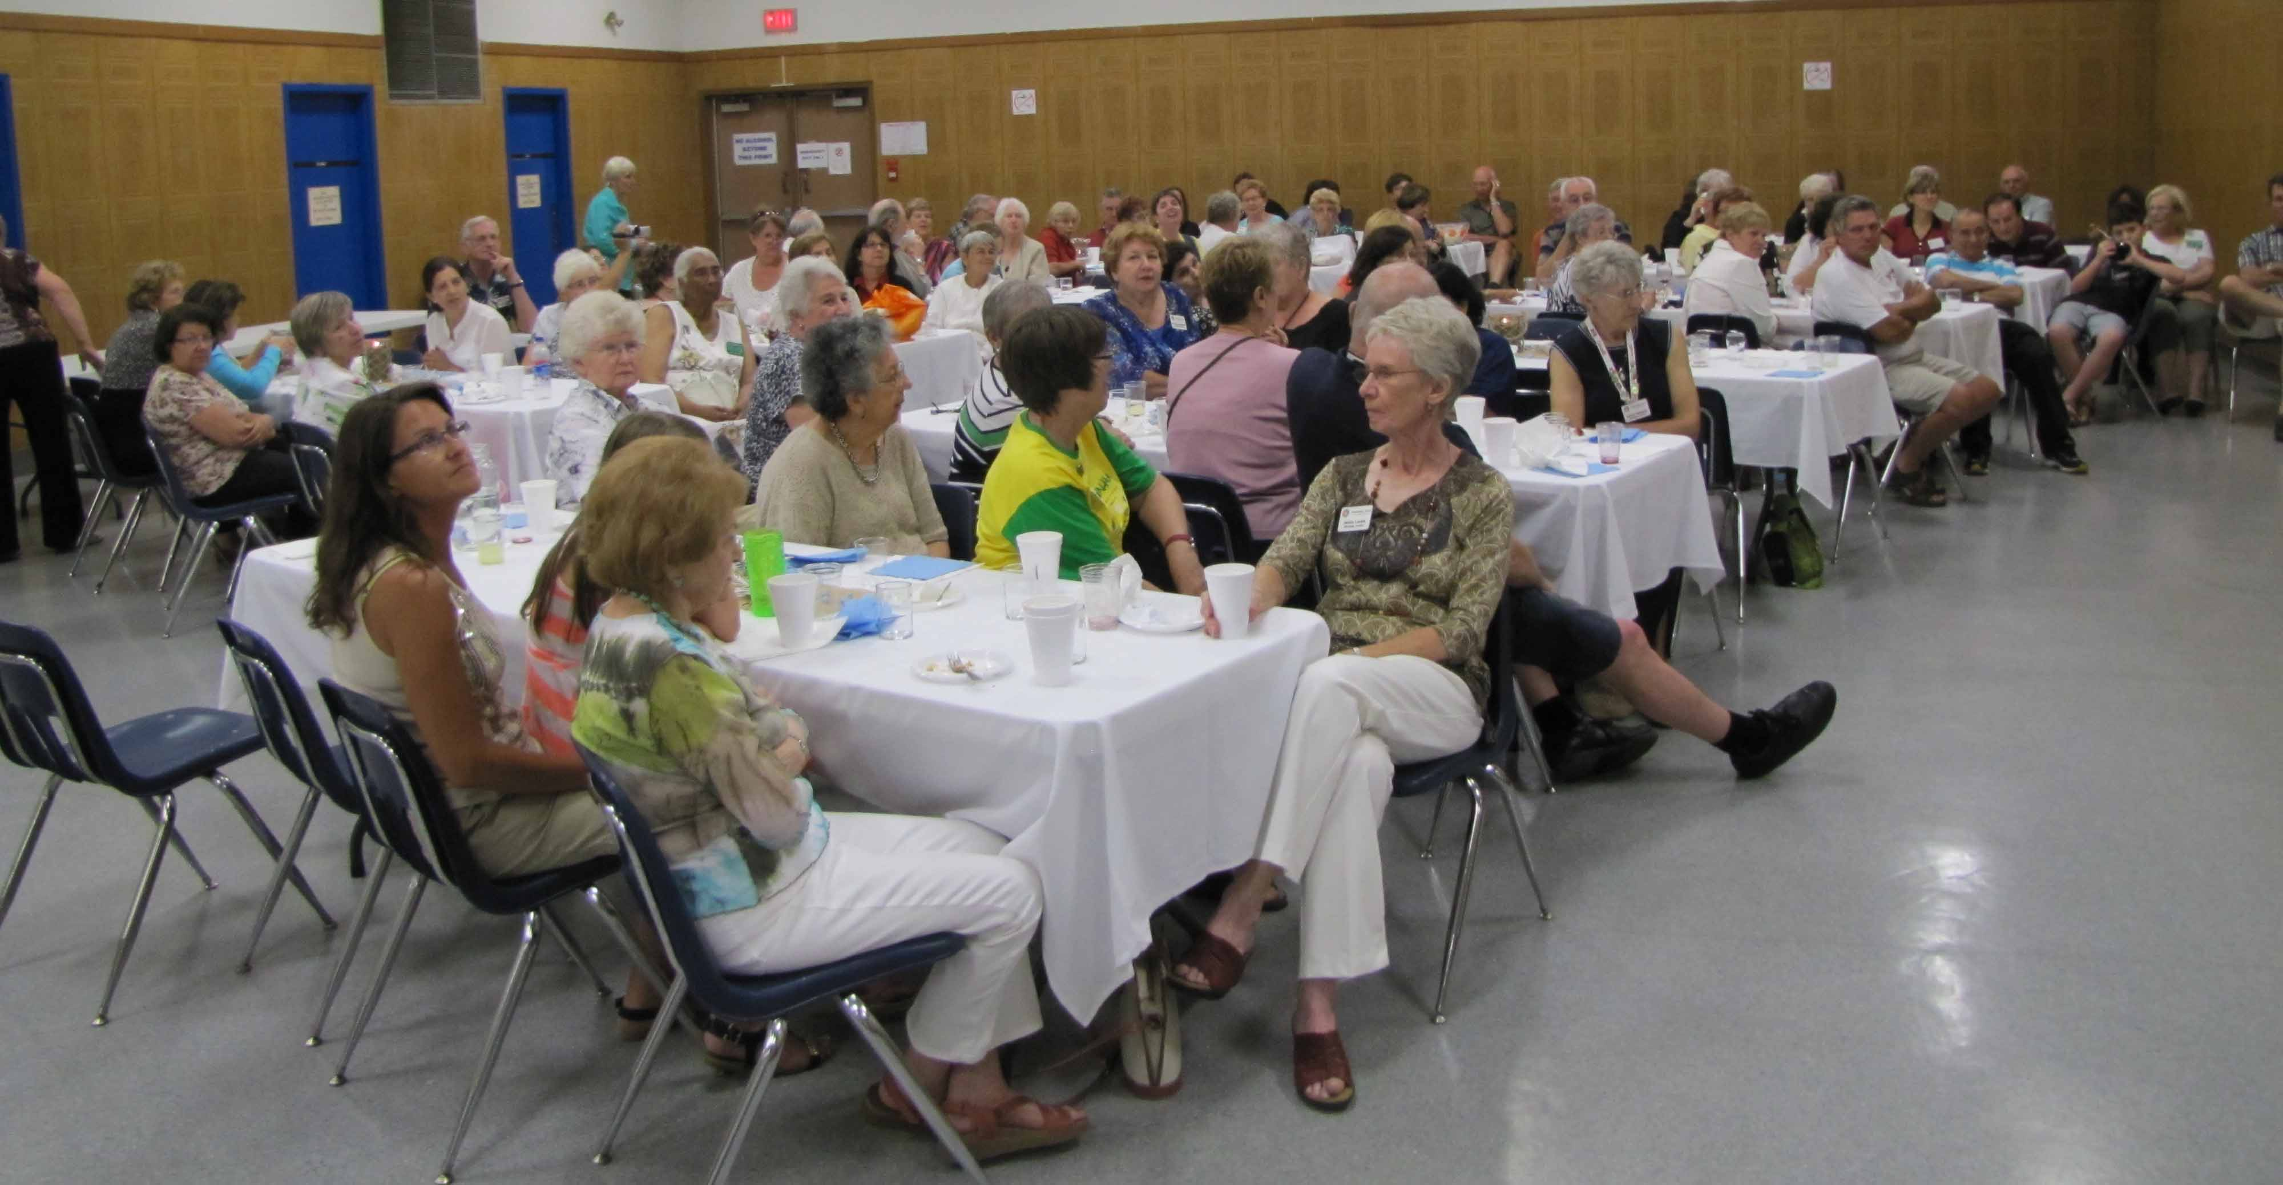

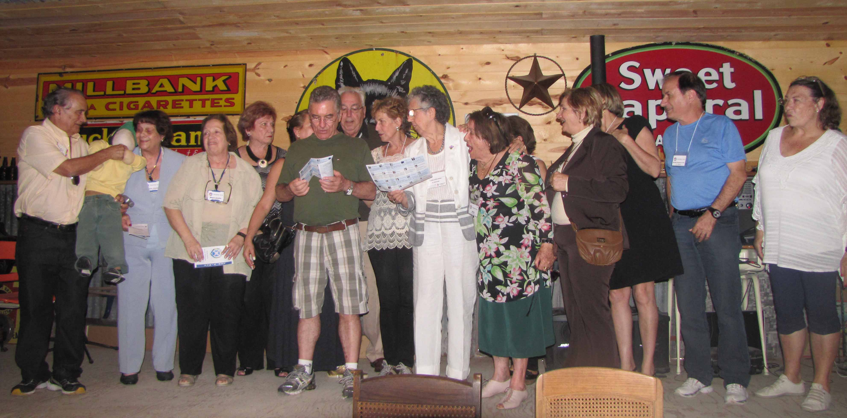
The Brazilian ambassadors voicing their appreciation for a great exchange at the Farewell Banquet - July 10th

Northern Illinois, USA Jim Kubas is the ED and Carol Frederickson is the Assistant ED. The dates for this exchange are September 18 to September 24. We are expecting 14 ambassadors. Activity sign-up sheets will be emailed/sent to members. These should be completed and returned to Jim Kubas no later than September 9th. Sign-up sheets will also be available and collected at our August meeting.
Contact: The Friendship Force of Winnipeg; Email: friendshipforcewpg@mts.net
Web site: www.friendshipforcewinnipeg.org
FFW Newsletter Editor/Publisher: James Kubas, Assistant Editor: Herb Schellenberg

Friendship Force International 127 Peachtree Street, Suite 501, Atlanta, Georgia 30303
Email: ffi@thefriendshipforce.org Web Site: www.thefriendshipforce.org

Outbound

Trujillo and Tarapoto, Peru. ED Paul Havixbeck; Assistant ED, Lorraine Franz . The dates for this exchange are October 7 to October 21, 2013. There are 21 ambassadors for this exchange: 10 from our club, 5 from FF Manitoba, 5 from other clubs in Canada and 1 from a club in USA. The exchange will be extended with an optional add-on for visiting Cusco, Machu Picchu, Lake Titicaca and Lima.

2014 Exchanges

The 2014 Outbound Exchange to Izmir, Turkey is scheduled for one week in April.

We will be hosting two inbound exchanges in 2014. Tentative dates for these exchanges are FF Comitan/FF Filibobos, Mexico in July and FF Saitama, Japan in September.

For each of the 2014 exchanges our club will require an Exchange Director and an Assistant Exchange Director.
It's not too early to consider becoming actively involved with these exchanges.

2015 Exchanges

The deadline for submitting our requests for our Outbound Exchanges for 2015 is November 1, 2013. Vote for your exchange preference by completing the request forms that have been sent out. Bring them to the August meeting or return them to Paul by September 11.
FFI - World Conferences
The 2013 conference will be from November 22 to November 25, 2013 in New Orleans, USA. About 75 Canadian FF members have registered with several from FFW. This will be the best attended FFI world conference.

The 2014 conference will be held in Auckland, New Zealand form October 14 to 16, 2014 at the Rendezvous Grand Hotel. Registration will begin in early 2014.

The 2015 World Conference has been announced. It is scheduled to take place in Vancouver, Canada from September 11 to 14, 2015


